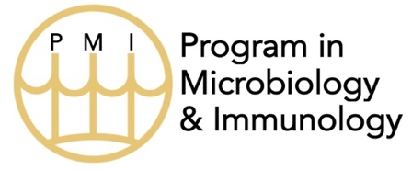
Yearly Student Evaluation - Mentor
Student name:
Date:
 | Outstanding | Excellent | Acceptable | Not  Acceptable | Unable to Assess
Effort in Lab
Reads Primary Literature
Independence
Analytical Skills
Ability to Perform Technical Tasks
Ability to Express
Self Verbally
Ability to Express
Self in Writing
Ability to Interact
with Others
Integrity in Lab Work
Contributes Intellectually to Lab
Overall Evaluation:
Please provide a brief synopsis of the student’s progress, noting any major concerns. Specifically comment on the status of current and upcoming publications*. This statement will be shared with the student. *All students are required to have published [or accepted for publication] at least one first-author manuscript of original research before defending their dissertation.

Optional: Please discuss any major concerns you have with the student that you feel should be brought to the attention of the PMI Evaluations Committee. This statement will NOT be shared with the student.

